**Influence of Spare Temperature on Dragon Fruits**

**Md.Jaber Hossain Department of Economics**

**University of Barishal**

**October 04,2024**

Abstract*:* Dragon fruit, known for its unique appearance and potential health benefits, has gained popularity globally.The dragon fruit market is thriving due to its unique appeal, potential health benefits, and growing consumer interest in exotic and nutritious fruits, with no signs of slowing down. Temperature is a crucial factor affecting its production, size, price, nutrition, color, flower blooming, market demand, cost, income, and willingness to cultivate more. Qualitative and quantitative data have been collected from farmers and analysand those data, including the effect of temperature, younger farmers are highly interested in cultivating, Red velvet variety is popular and YouTube is the main source of information. The findings implemented the need for climate-resilient agricultural practices, knowledge sharing, and targeted support to ensure sustainable dragon fruit cultivation in Jessore and similar regions, suggesting utilization techniques like shade cloth, temperature-controlled greenhouses, and suitable irrigation systems to mitigate extreme temperatures and maintain optimal conditions, ultimately offering valuable insights for policymakers, researchers, and farmers navigating the complexities of this emerging agricultural sector.

*Key word* :Dragon Fruits,Temperature,Effect,Climate

# Chapter 01 : Introduction

## History of Background

Dragon fruit known as pitaya, is a tropical and subtropical fruit that has gained popularity worldwide due to its unique appearance, delicious taste, and potential health benefits(Le, T. L., Huynh, N., & Quintela-Alonso, P. 2021).The plant is known by many names, such as dragon fruit, pitaya, pitahaya, night-blooming cereus, strawberry pear, Belle of the Night, Cinderella plant (Perween et al. 2018). Maximum germination percentage is at 30°C, 35°C, and 40°C, germination percentage decrease at temperatures above 40°C and below 25°C. Pollen germination do not occur at 45 °C (Mach, M. M., Chowdhury, A. K., Murata, T., and Yonemoto, Y. (2006). It has several health benefits including its ability to aid in weight loss, improve digestion, reduce LDL cholesterol in the blood and strengthen the immune system.(Hossain, F. M., Numan, S. M. N., & Akhtar, S. 2021).The dragon fruit has the potential market and high demand in the domestic market.Dragon has a lot of demand for export markets too( Mansyah, E., Muas, I., & Yuliati, S. 2019). For this reason,dragon fruits are commercially cultivated luxuriantly in our area (Bangladesh Dost,N.2021).

## Statement of the Problem

The successful cultivation of dragon fruit depends on several factors, one of which is temperature. Temperature is a crucial environmental factor that profoundly affects the growth, development, and overall quality of dragon fruit. As global climate patterns continue to change, understanding how dragon fruit responds to changes in temperature is essential for sustainable production and maintaining fruit quality.

This report aims to explore the impact of spare temperature on dragon fruit cultivation and its subsequent effects on fruit quality. I will investigate the influence of various aspects of dragon fruit growth, such as flowering and fruit sets. Ultimately, this research contributes to the broader goal of promoting sustainable agriculture and ensuring a consistent supply of high-quality dragon fruit to meet the demands of consumers worldwide.

## Objective of the Study

To investigate the effect of spare temperature on the production, price and spoiling of the level of the dragon fruits.

# Chapter 02 : Literature Review

## Available literature

Dragon has many nutritional value and health benefit (Hossain, F. M., Numan, S. M. N., & Akhtar, S. 2021).The temperature condition and storage method vitro germination of dragon fruints are studied( Macha, M. M., Chowdhury, A. K., MURATA, T., & YONEMOTO, Y. 2006).It has many cancer destroying materials (Aghajanpour, M., Nazer, M. R., Obeidavi, Z., Akbari, M., Ezati, P., & Kor, N. M. 2017).Deagon fruits has international demand (Karunakaran, G., Arivalagan, M., & Sriram, S. 2019, September).The effect of temperature induced fruit rot is discussed ( Jitareerat, P., Sripong, K., Masaya, K., Aiamla-or, S., & Uthairatanakij, A. 2018).The effect of temperature on fresh cut fruits is discussed ( Sim, H. L., Hong, Y. K., Yoon, W. B., & Yuk, H. G. 2013).Effects of disease ,climate,maturity of the Viatmen have been studied ( Tien, N. N. T., Le, N. L., Khoi, T. T., & Richel, A. 2022).The effect of hot water and packing time has been studied (Lum, M. S., & Norazira, M. A. 2011).

## Research Gap

From the available literature, it has been seen that there is existing research on dragon fruit cultivation in various regions. No such study has been done in Jessore region yet,this study is intended to analyze the specific region at Jashore of Bangladesh.

# Chapter 03: Methods

## Study Area Selection

The research commenced by carefully selecting the study area in Jashore District, Bangladesh. Jashore District, which is one of the 64 districts in Bangladesh, was chosen due to its significance in dragon fruit cultivation. Within Jashore District, eight Upazilas (sub- districts) were identified for consideration: Abhaynagar Upazila, Bagherpara Upazila, Chaugachha Upazila, Jessore Sadar Upazila, Jhikargachha Upazila, Keshabpur Upazila, Manirampur Upazila, and Sharsha Upazila. Of these, we focused our attention on Chowgacha Upazila, which consists of ten unions: Dhuliani, Hakimpur, Jagadishpur, Swarupdah, Narayanpur, Pashapole, Patibila, Phulsara, Singhajhuli, and Sukpukuria. For the purposes of this study, Patibila-7410 Village within the Patibila Union was selected as the primary research location.

## Production Season and Crop Selection

Dragon fruit production occurs over a span of six months, covering the summer, rainy, and autumn seasons. For the purpose of this study, we specifically focused on the months of May and June, which are critical for dragon fruit cultivation. Dragon fruits were chosen as the primary crop for our investigation due to their relevance in the recent time in the local agricultural context.

## Sampling

In the village of Patibila, a total of 50 farmers were identified as potential participants for our study. However, to ensure a manageable and representative sample, we selected 16 farmers for primary data collection. The data collection process involved a combination of methods, including face-to-face interviews, phone calls, and Focus Group discussions, all of which took place during the months of May and June 2023.

## Data Analysis Techniques

Our study took both qualitative and quantitative data to comprehensively examine the impact of very high temperatures on dragon fruit cultivation. The analysis of quantitative data was carried out using statistical tools, primarily Microsoft Excel and Microsoft Word, to present the findings.Descriptive Statistics: We calculated various descriptive statistics to summarize and describe the data, including measures such as the maximum and minimum values. Additionally, we prepared Frequency Distribution Tables to provide a chart and a clear overview of the data distribution.

# Chapter 04 : Result and Discussion

## Age of the Farmers

From the field survey, it has been found that there are different ages people are involved to cultivating land.Total 16 farmers were surveyed, and their ages were grouped into different ranges. The majority of the farmers, 37.5%, fell into the age range of 21 to 27 years. Meanwhile, 6.25% of the farmers were between 28 and 34 years old, and 18.75% were distributed evenly across three age groups: 35-41, 42-48, and 49-55.

Table No 01: Farmers age

|  |  |  |
| --- | --- | --- |
| **Range** | **Frequency** | **Percentage** |
| 21-27 | 6 | 37.5 |
| 28-34 | 1 | 6.25 |
| 35-41 | 3 | 18.75 |
| 42-48 | 3 | 18.75 |
| 49-55 | 3 | 18.75 |
| **Total** | **16** | **100** |

(Source:Field work,2023.)

The above Table 01 shows that young people are comparatively interested to cultivate dragon fruits.It is also showing a degree of diversity among middle-aged and older farmers. Understanding this age distribution can be valuable for crafting targeted agricultural policies and support programs tailored to different age groups within the farming community.

## Educational level of the Farmers

Education empowers individuals to grow, adapt, and contribute to society,enable personal development .It plays a crucial role in improving agricultural outcomes, promoting innovation, and addressing the evolving challenges faced by the farming community.

Table No 02: Farmers educational level

|  |  |  |
| --- | --- | --- |
| **Range** | **Frequency** | **Percentage** |
| 1-2 | 1 | 6.25 |
| 3-4 | 1 | 6.25 |
| 5-6 | 5 | 31.25 |
| 7-8 | 2 | 12.5 |
| 9-10 | 3 | 18.75 |
| 11-12 | 4 | 25 |
| **Total** | **16** | **100** |

(Source:Field work,2023.)

The above Table No 02 provides a concise breakdown of the educational backgrounds of the sample of 16 farmers.It categorizes them into six educational ranges, showing that the largest group (31.25%) completed 5-6 years of education.This data illustrates the educational diversity within the farming community.

## Cultivation land of the Farmer

Land used for growing various crops such as grains, fruits, vegetables, and raising livestock for meat, dairy, and other agricultural products.The below bar graph portrays the amount of dragon fruits land.

Chart No 01: Farmers land

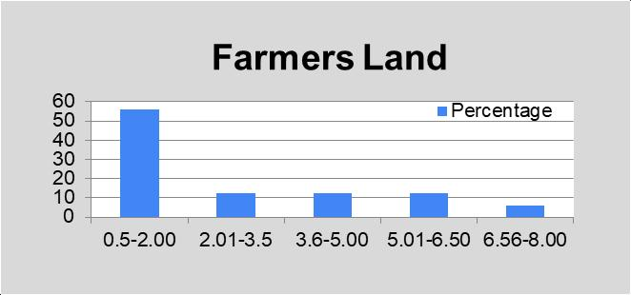

(Source:Field work,2023.)

Here, 56.25% farmer used 0.5-2.00 land because of the shortage money.Some rich farmer cultivated their land on a large scale.

## Spoil of the Dragon Flower

The flowering stage is the first stage to produce fruits. Maximum germination percentage was observed at 30°C, 35°C, and 40°C, germination percentage decreased at temperatures above 40°C and below 25°C. Pollen germination did not occur at 45 °C (Mach,

M. M., Chowdhury, A. K., Murata, T., and Yonemoto, Y. (2006).

Table No 03: Current Year Table No 04: Past Year

|  |  |  |
| --- | --- | --- |
| **Range** | **Frequency** | **Percentage** |
| 55-62 | 2 | 12.5 |
| 63-70 | 4 | 25 |
| 71-78 | 3 | 18.75 |
| 79-86 | 5 | 31.25 |
| 87-94 | 1 | 6.25 |
| 95-102 | 1 | 6.25 |
| **Total** | **16** | **100** |

|  |  |  |
| --- | --- | --- |
| **Range** | **Frequency** | **Percenaage** |
| 4-9 | 2 | 12.5 |
| 10-15 | 6 | 37.5 |
| 16-21 | 2 | 12.5 |
| 22-27 | 2 | 12.5 |
| 28-33 | 3 | 18.75 |
| 34-39 | 1 | 6.25 |
| **Total** | **16** | **100** |

(Source:Field work,2023.) (Source:Field work,2023.)

The above Table No 03 and Table No 04 shows the flower spoiled, due to high temperature. Table No 03: The current year portrays that the largest group (31.25%) is situated between (79-86).Table No 04: The past year shows that the largest group (18.75%) is situated between (28-33).There are huge flower spoil difference between current year and past year.

## Price of the Dragon Fruits

The demand for the big flower is higher than the smaller fruits. Due to the high temperature, Table no 05, the current year's fruits have become small, and the price is less than the past year. The highest percentage is situated between the price level ( 180-189).

Table No 05: Current Price Table No 06: Past Year Price

|  |  |  |
| --- | --- | --- |
| **Range** | **Frequency** | **Percentage** |
| 140-149 | 1 | 6.25 |
| 150-159 | 2 | 12.5 |
| 160-169 | 2 | 12.5 |
| 170-179 | 3 | 18.75 |
| 180-189 | 7 | 43.75 |
| 189< | 1 | 6.25 |
| **Total** | **16** | **100** |

|  |  |  |
| --- | --- | --- |
| **Range** | **Frequency** | **Percentage** |
| 200-206 | 5 | 31.25 |
| 207-213 | 2 | 12.5 |
| 214-220 | 4 | 25 |
| 221-227 | 1 | 6.25 |
| 228-234 | 1 | 6.25 |
| 235-241 | 3 | 18.75 |
| **Total** | **16** | **100** |

(Source:Field work,2023.)

(Source:Field work,2023.)

The above Table no 06 past year, shows that most of the farmers sold their fruit between the price level ( 200-206 ). Some farmers sold their fruits, a higher price level (235- 241).

## Production Level of the Dragon Fruits

Here, discussed the production level of dragon fruits for only two months. This table offers a clear breakdown of production distribution across various ranges, providing valuable insights into the distribution of production levels.

Table No 07: Current Production level Table No 08:Past Year Production level

|  |  |  |
| --- | --- | --- |
| **Range** | **Frequenc y** | **Percentage** |
| 20-64 | 2 | 12.5 |
| 65-109 | 2 | 12.5 |
| 110-154 | 5 | 31.25 |
| 155-199 | 2 | 12.5 |
| 200-244 | 2 | 12.5 |
| 245-289 | 3 | 18.75 |
| **Total** | **16** | **100** |

|  |  |  |
| --- | --- | --- |
| **Range** | **Frequency** | **Percentage** |
| 171-270 | 5 | 31.25 |
| 271-370 | 3 | 18.75 |
| 371-470 | 6 | 37.5 |
| 471-570 | 1 | 6.25 |
| 571-670 | 0 | 0 |
| 671-770 | 1 | 6.25 |
| **Total** | **16** | **100** |

(Source:Field work,2023.)

(Source:Field work,2023.)

The above, Table No 07: Current Production level, shows that most of the farmer's production level is situated in the range(110-154)per Bigha.Table No 08: Past Year Production level, shows that most of the farmer's production level is situated in the range(371-470) per Bigha. The past year's production is higher than the current year.

## Income Level of the Dragon Fruits

Income in agricultural products refers to the revenue or money generated from the sale of agricultural commodities or products produced on a farm or agricultural operation. This income can come from various sources within the agricultural sector.Here, are discussed the income that came from fruit selling.

Table No 09: Current Income Level

|  |  |  |
| --- | --- | --- |
| **Range** | **Frequency** | **Percentage** |
| 4000-13999 | 3 | 18.75 |
| 14000-23999 | 4 | 25 |
| 24000-33999 | 4 | 25 |
| 34000-43999 | 3 | 18.75 |
| 44000-53999 | 2 | 12.5 |
| **Total** | 16 | 100 |

(Source:Field work,2023.)

The above,Table No 09: Current Income Level,portrays that the income level of the farmers.The two ranges( 14000-23999,24000-33999 ) are the same percentage contain that is

the highest percent (25%).The below,Table No 10 :Past Year Income level,shows that the most of the farmer income confined 75001 to 95000.

Table No 10 :Past Year Income level

|  |  |  |
| --- | --- | --- |
| **Range** | **Frequency** | **Percentage** |
| 35001-55000 | 4 | 25 |
| 55001-75000 | 3 | 18.75 |
| 75001-95000 | 7 | 43.75 |
| 95001-115000 | 1 | 6.25 |
| 115001-135000 | 0 | 0 |
| 135001-155000 | 1 | 6.25 |
| **Total** | **16** | **100** |

(Source:Field work,2023.)

Income this year is less than last year. The past year's income variation of the farmers was less.The present year income variation is more.

## Expenditure Level of the Dragon Fruits

Table No 11 and Table No 12 present expenditure data for the current year and the past year, respectively.These tables provide insights into the distribution of expenditures within various income ranges, offering valuable information for analyzing spending patterns within a specific farmer or group.

Table No 11: Current Year Expenditure Level

|  |  |  |
| --- | --- | --- |
| **Range** | **Frequency** | **Percentage** |
| 45000-54999 | 3 | 18.75 |
| 55000-64999 | 2 | 12.5 |
| 65000-74999 | 3 | 18.75 |
| 75000-84999 | 1 | 6.25 |
| 85000-94999 | 3 | 18.75 |
| 95000-105999 | 4 | 25 |
| **Total** | **16** | **100** |

(Source:Field work,2023.)

The above, Table No 11, shows that the majority of the farmer in the study (25%) falls within the expenditure range of 95,000 to 105,999 units. Another significant portion (18.75%) has expenditures in the 45,000 to 54,999 and 65,000 to 74,999 ranges.The below, Table No 12, shows that the majority of the population (50%) had expenditures within the range of 27,500 to 77,499 units, indicating a concentration of spending in this lower-income bracket.A significant portion (18.75%) of the population also had expenditures in the ranges of 77,500 to 127,499 and 127,500 to 177,499.

Table No 12: Past Year Expenditure Level

|  |  |  |
| --- | --- | --- |
| **Range** | **Frequency** | **Percentage** |

|  |  |  |
| --- | --- | --- |
| 27500-77499 | 8 | 50 |
| 77500-127499 | 3 | 18.75 |
| 127500-177499 | 3 | 18.75 |
| 177500-227499 | 1 | 6.25 |
| 227500-277499 | 1 | 6.25 |
| **Total** | 16 | 100 |

(Source:Field work,2023.)

The expenditure of the farmers is almost the same, there are few differences in expenditure among the farmers.

## Agricultural Loan

The chart shows that 56 % farmer got agricultural loan and 44% farmer did not get agricultural loan.So,agricultural loan help the farmers to cultivate dragon fruits.

Chart No 02: Agricultural Loan

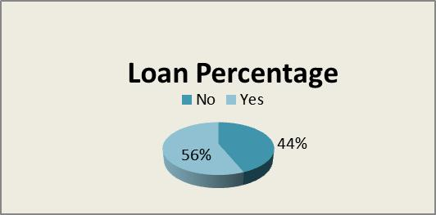

(Source:Field work,2023.)

## Varity Name

There are many types of dragon fruits.Mainly three types of dragon fruits are cultivated in our area.These are Red Velvet Dragon,Bari 1,Singapore Pelora.

Chart No 03: Variety Name

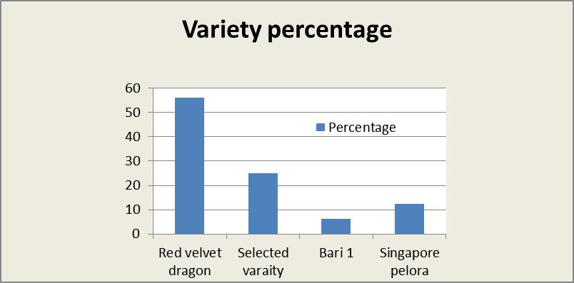

The above Chart No. 03 provides a snapshot of Dragon Fruit varieties, showcasing their distribution by percentage. The Red Velvet Dragon dominates the chart with 56.25%, followed by the Selected variety at 25%. Bari 1 and Singapore Pelora make up smaller percentages, with 6.25% and 12.5% respectively. This chart offers a quick overview of the prevalence of different Dragon Fruit varieties.

## Getting Information Way of Percentage

The below Chart No. 04 illustrates the sources of information and their respective percentages in the given data. YouTube stands out as the most popular source, accounting for 50% of the information, followed by information obtained from neighbors at 25%. Newspapers contribute a smaller share at 6.25%, while online sources make up 18.75%. This chart provides insight into the various ways people acquire information, with YouTube being the dominant choice.

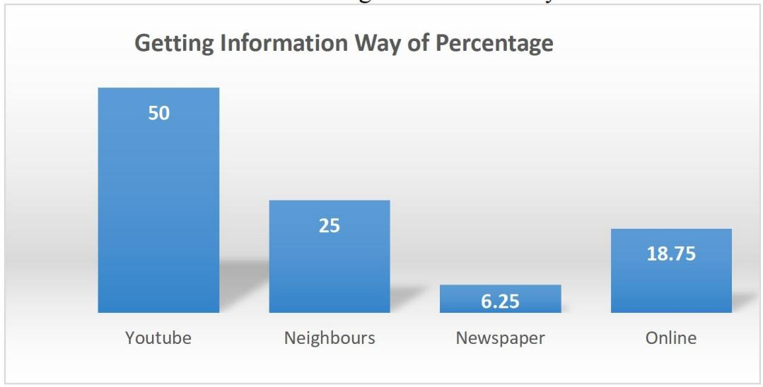Chart No 04:Getting Information Way

(Source:Field work,2023.)

This is the new fruits cultivation in our country.So ,getting information is an important thing.Most of the farmer use you tube to get information.

# Chapter 04 : Conclusion

This research study has delved into the critical factors influencing dragon fruit cultivation in the Jashore region of Bangladesh, with a specific focus on the impact of temperature on various aspects of production. The findings reveal that temperature fluctuations play a significant role in dragon fruit cultivation, affecting factors such as flowering, fruit size, and ultimately, the income of farmers. Younger farmers are more inclined towards dragon fruit cultivation, indicating a potential shift in agricultural demographics. Furthermore, the research unveiled the prevalence of the Red Velvet Dragon as the dominant dragon fruit variety in the region. Education levels among farmers vary, highlighting the need for tailored support and information dissemination strategies. While agricultural loans are accessed by a significant portion of farmers, further research and policy

attention are needed to optimize the allocation of resources. The study underscores the importance of information sources, with YouTube emerging as a prominent channel, These findings underscore the importance of climate-resilient agricultural practices, knowledge dissemination, and targeted support to ensure sustainable dragon fruit cultivation in Jashore and similar regions.Overall, techniques such as shade cloth and temperature-controlled greenhouses have been employed to mitigate extreme temperatures and implement suitable irrigation systems and maintain optimal conditions for dragon fruit cultivation . This research contributes to our understanding of the complexities of dragon fruit farming and offers insights for policymakers, researchers, and farmers aiming to navigate the challenges and opportunities in this emerging agricultural sector.

# Reference:

1. Macha, M. M., Chowdhury, A. K., MURATA, T., & YONEMOTO, Y. (2006). Effect of artificial media, temperature conditions and storage methods on in vitro germination of dragon fruit (Hylocereus undatus Britt & Rose) pollen. *Japanese Journal of Tropical Agriculture*, *50*(1), 51-56.
2. Hossain, F. M., Numan, S. M. N., & Akhtar, S. (2021). Cultivation, nutritional value, and health benefits of Dragon Fruit (Hylocereus spp.): A Review. *International Journal of Horticultural Science and Technology*, *8*(3), 259-269.
3. Le, T. L., Huynh, N., & Quintela-Alonso, P. (2021). Dragon fruit: A review of health benefits and nutrients and its sustainable development under climate changes in Vietnam. *Czech Journal of Food Sciences*, *39*(2), 71-94.
4. Patwary, M. A., Rahman, M. H., Barua, H., Sarkar, S., & Alam, M. S. (2013). Study on the growth and development of two dragon fruit (Hylocereus undatus) genotypes. *The Agriculturists*, *11*(2), 52-57.
5. Aghajanpour, M., Nazer, M. R., Obeidavi, Z., Akbari, M., Ezati, P., & Kor, N. M. (2017). Functional foods and their role in cancer prevention and health promotion: a comprehensive review. *American journal of cancer research*, *7*(4), 740.
6. Mansyah, E., Muas, I., & Yuliati, S. Dragon Fruit Production and Marketing in Indonesia: Standard Quality in the Global and Regional Levels Dragon Fruit Production and Marketing in Indonesia: Standard Quality in the Global and Regional Levels.
7. Perween T., Mandal K.K., Hasan M.A. (2018): Dragon fruit: An exotic super future fruit of India. Journal of Pharmacognosy and Phytochemistry, 7: 1022–1026.
8. Karunakaran, G., Arivalagan, M., & Sriram, S. (2019, September). Dragon fruit country report from India. “Dragon Fruit Network: Marketing and the Whole Value Chain” and Steering Committee Meeting.
9. [https://bangladeshpost.net/posts/commercial-cultivation-of-dragon-fruit-in-jashore-](https://bangladeshpost.net/posts/commercial-cultivation-of-dragon-fruit-in-jashore-65872#%3A~%3Atext%3DChaugachha%20upazila%20has%2CNarayanpur%2C%20Barakhanpur%20village) 65872#:~:text=Chaugachha%20upazila%20has,Narayanpur%2C%20Barakhanpur%20village.
10. Jitareerat, P., Sripong, K., Masaya, K., Aiamla-or, S., & Uthairatanakij, A. (2018). Combined effects of food additives and heat treatment on fruit rot disease and quality of harvested dragon fruit. *Agriculture and Natural Resources*, *52*(6), 543-549.
11. Sim, H. L., Hong, Y. K., Yoon, W. B., & Yuk, H. G. (2013). Behavior of Salmonella spp. and natural microbiota on fresh-cut dragon fruits at different storage temperatures. *International journal of food microbiology*, *160*(3), 239-244.
12. Tien, N. N. T., Le, N. L., Khoi, T. T., & Richel, A. (2022). Influence of location, weather condition, maturity, and plant disease on chemical profiles of dragon fruit (Hylocereus spp.) branches grown in Vietnam. *Biomass Conversion and Biorefinery*, 1-13.
13. Lum, M. S., & Norazira, M. A. (2011). Effects of hot water, submergence time and storage duration on quality of dragon fruit (Hylocereus polyrhizus). *Journal of Agricultural Science*, *3*(1), 146.